**WEEK-5**

**MICROSERVICES WITH SPRING BOOT 3 AND SPRING CLOUD**

**MICROSERVICES WITH API GATEWAY**

**CREATING MICROSERVICES FOR ACCOUNT AND LOAN**

**AccountController.java**

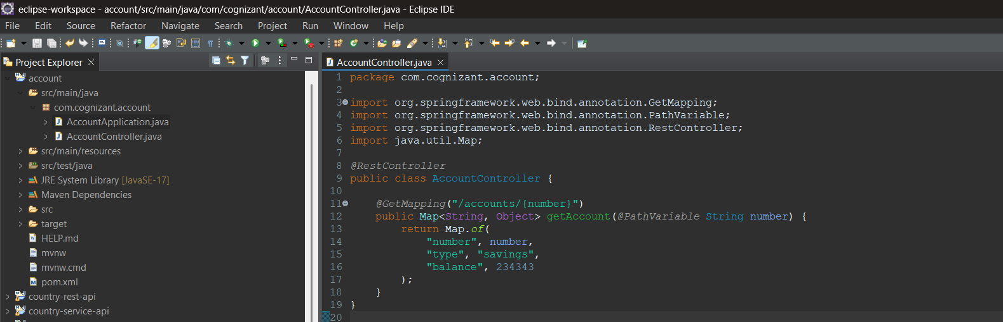

**AccountApplication.java**

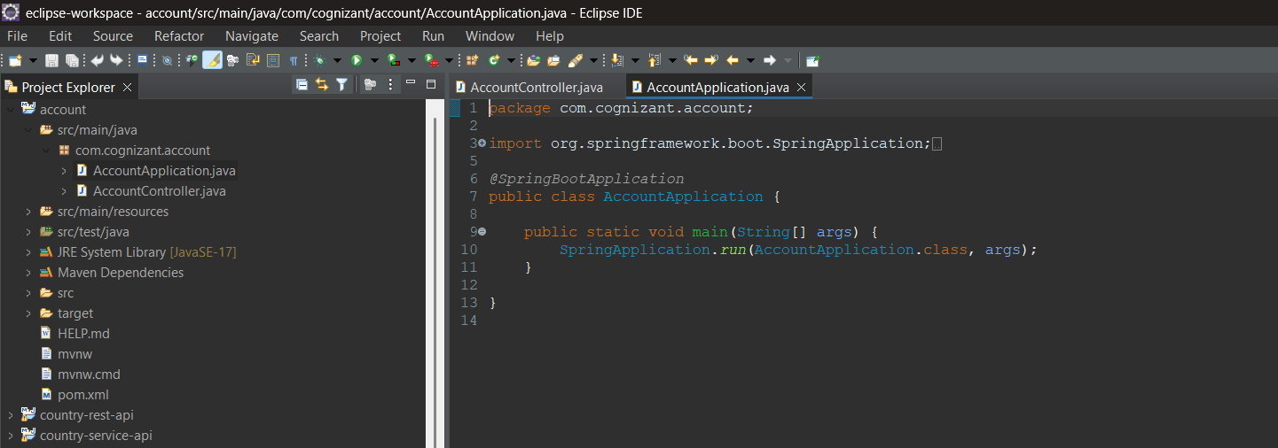

**Account Console**

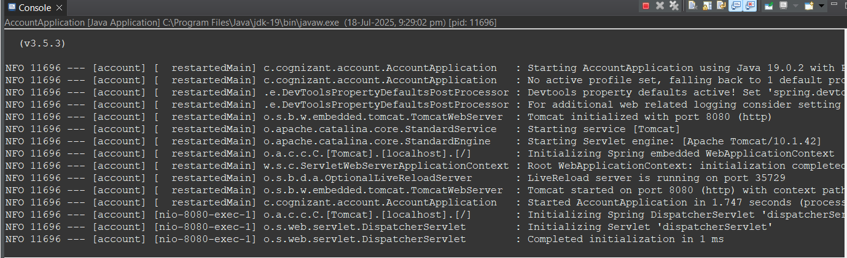

**Postman**

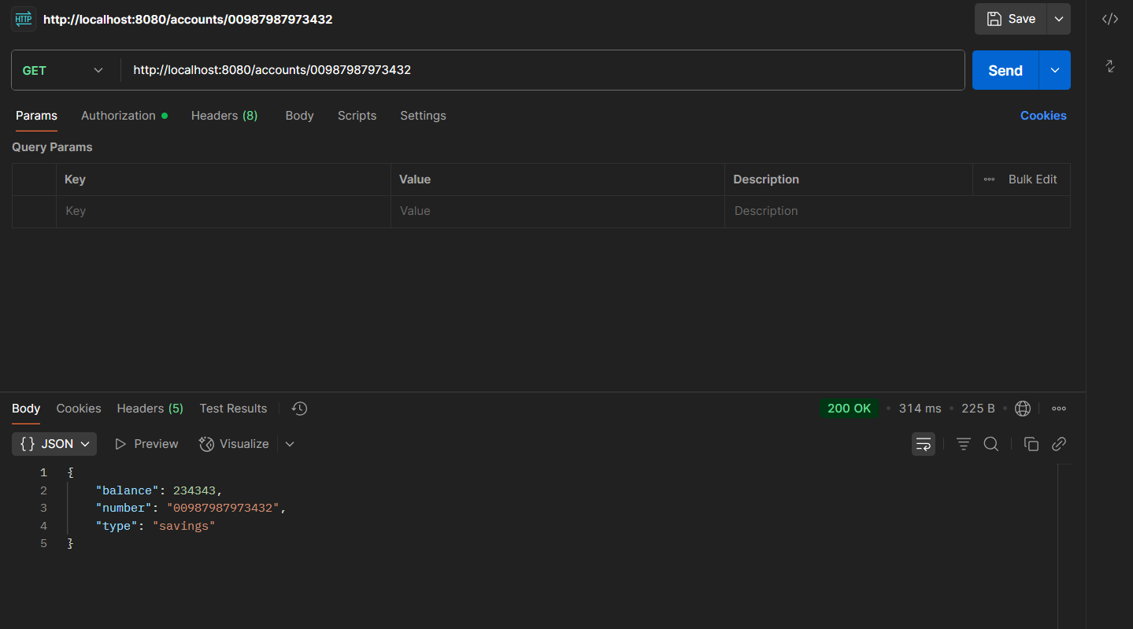

**LoanController.java**

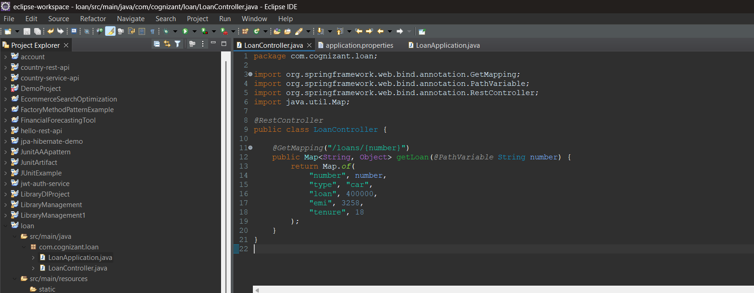

**Application.properties**

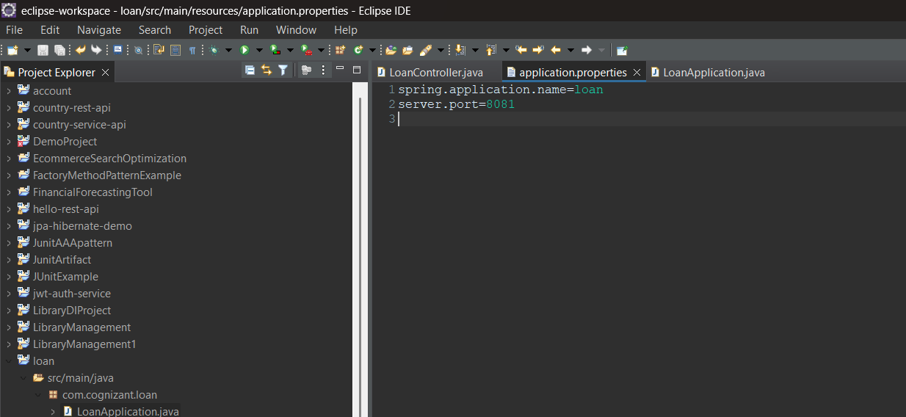

**LoanApplication.java**

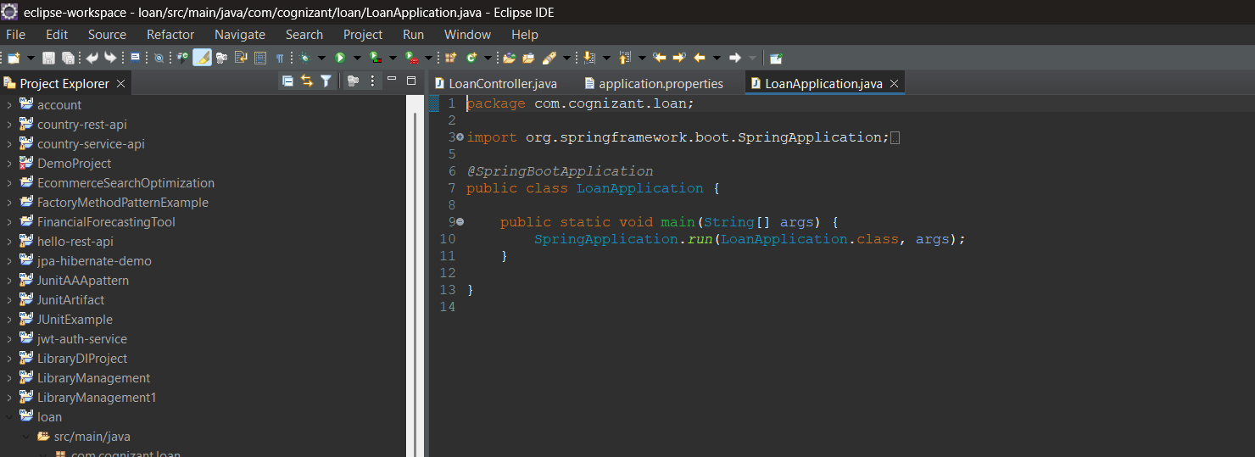**Loan Console**

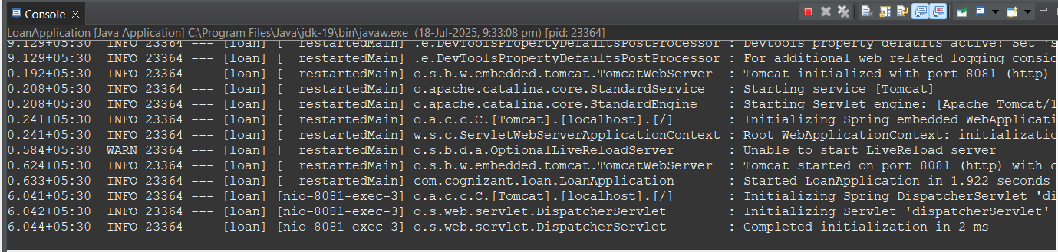

**Postman**

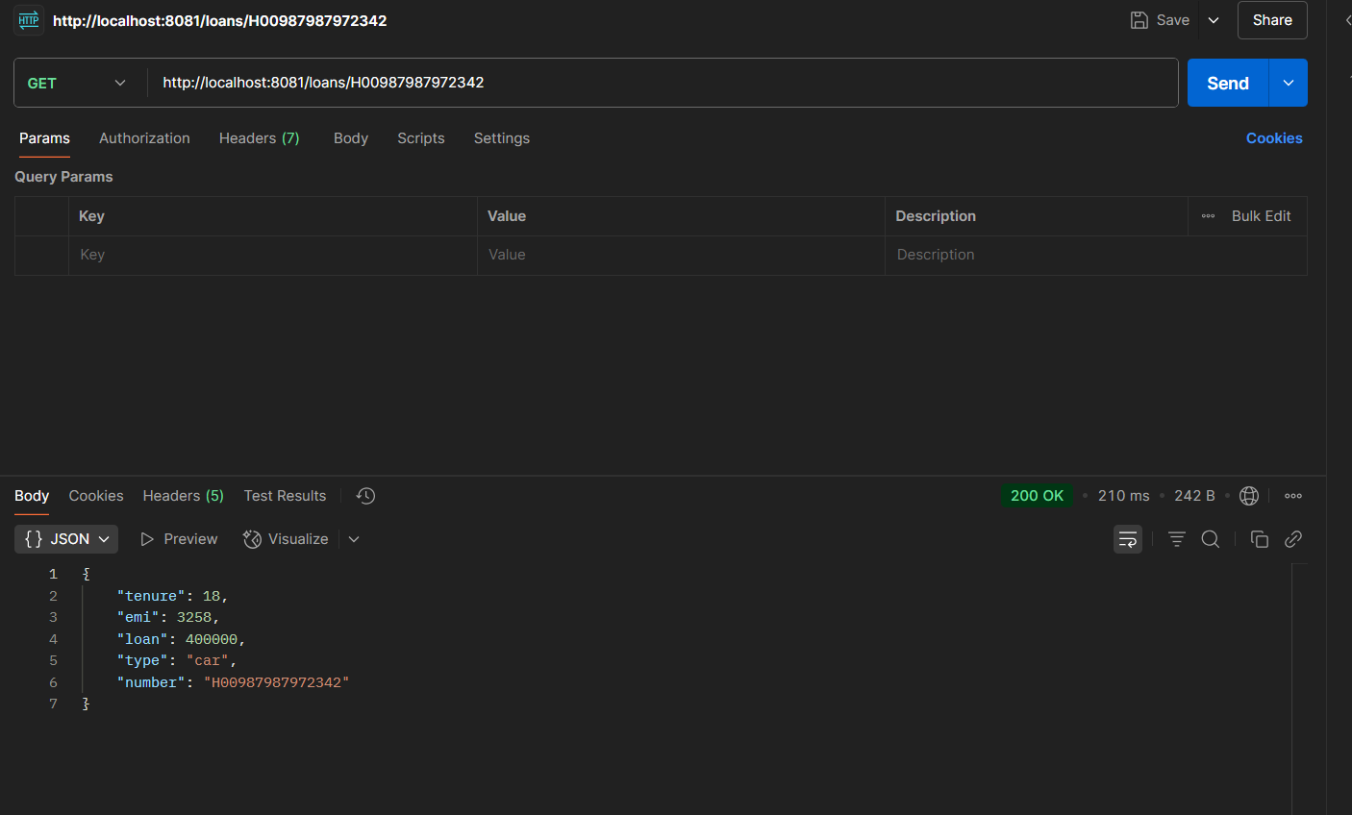

**Switching consoles**

